**LAB EXPERIMENT NO.**

**10**

**LIST OF TASKS**

|  |  |
| --- | --- |
| TASK NO | OBJECTIVE |
| 01 | 1. Implement box plot and histogram for IRIS Data set    1. Read any file and change column name and type    2. Remove initial comments from data read from file.    3. Remove 3rd column    4. Filter out rows of any data which is useless    5. Write final data in csv format    6. Enter name and description for all nodes in the workflow    7. Save and execute workflow exercise 1. |

**Submitted On:**

**____________**

**Task No. 1:** Implement box plot and histogram for IRIS Data set

* 1. Read any file and change column name and type
  2. Remove initial comments from data read from file.
  3. Remove 3rd column
  4. Filter out rows of any data which is useless
  5. Write final data in csv format
  6. Enter name and description for all nodes in the workflow
  7. Save and execute workflow exercise 1.

**Solution:**

1. **Read any file and change column name and type**

1. **Remove initial comments from data read from file.**
2. Table

   Description automatically generated**Remove 3rd column**

1. 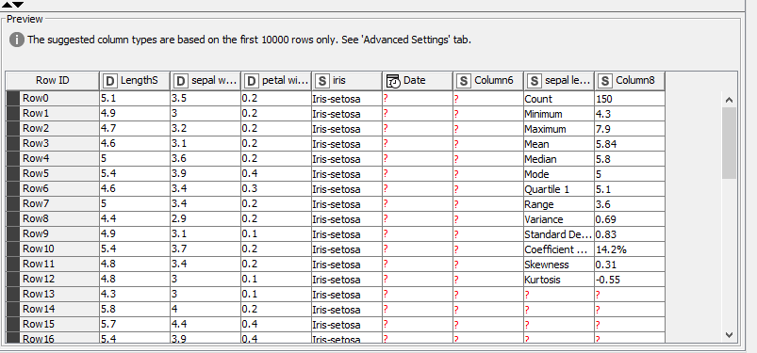**Filter out rows of any data which is useless**
2. **Write final data in csv format**

